[Add relevant Ministry/Partner logos]

Project title: [Enter project title]

TAP project plan

Project overview

Goals, objectives and outcomes

Goal: [Enter project goal]

Objectives:
- [Step out objectives]

Outcomes:
- [Step out outcomes]

See Annex A for background on Training in Assistive Products (TAP).

Locations and timeframe

Locations: [Which are the selected service providers and where are they located? List below]

 | Region/District | Service provider  (name) | Health service level  (community / primary / secondary / tertiary)
1
2
3
4
5
6
7
8
9
10

Timeframe: [For how many months is project roll out planned?]

Activity work plan: [Adjust activities and months as required]

 | Activity | Month
 |  | 1 | 2 | 3 |  | 4 |  | 5 |  | 6 |  | 7 |  | 8
1 | Planning
 | Identify key partners (section 2.1)
 | - Service locations/providers
 | - Learners (nominated personnel from service locations/providers)
 | - Mentors (nominated personnel to support Learners)
 | - Implementation supporting partner/s (e.g. for training delivery or referral and awareness raising about services)
 | Training plan (section 3)
 | Assistive products, storage and stock distribution plan (section 4)
 | Referral pathways (section 5)
 | Monitoring, evaluation and learning (MEL) plan and prepare service data system (section 6)
 | Data management plan (section 8)
2 | Preparation
 | Meetings with service managers to give TAP briefing and agree plans (including release of staff for training, protected time and dedicated space for service provision, including storage)
 | Training preparations including:
 | - Mentors preparation and briefing
 | - Learners preparation
 | - Any training logistics required
 | Service provision preparation
3 | Implementation
 | Training – Learners take online modules and participate in group role play and discussion (as per Training plan)
 | Stock distribution – Assistive products provided to service locations (as per Storage and stock distribution plan)
 | Service provision – Learners provide products with regular Mentor supervision, support and monitoring to ensure safe practice
 | Awareness raising – as required/planned
4 | Monitoring, evaluation and learning
 | Data collection (as per MEL plan)
 | Data analysis and reporting

Implementation arrangements

Implementing partners

The table below identifies the implementing partners and their roles: [Which are the key partners? List below and define roles]

Partner (add/delete as appropriate) | Role
Ministry of Health
WHO Country Office
WHO Regional Office
WHO HQ
Implementing partner/s
Service partners
Other

Selection of Learners

See Annex B for target learner profile and criteria for selection of learners.

Service providers or learner groups | Number |  |  | Learner profiles | Modules each group will take
 | Male | Female | Other | Current role (knowledge/skills/exposure to assistive products) and expected role in assistive products after training | [Enter selected modules]
[Add lines as required as per training plan]

Selection of Mentors

See Annex C for role of Mentors and criteria for selection of mentors for each module stream.

The table below identifies Mentors for each health facility/location:

 | Region/District | Service provider  (name) | Mentor | Mentor background/experience
1
2
3
4
5
6
7
8
9
10

[OR]

The table below identified Mentors for each module stream:

Module stream | Mentor(s) | Mentor(s) background/experience
[Add stream]
[Add module]
[Add module]
[Add stream]
[Add module]
[Add module]
[Add lines as required]

Communication platform for mentors to support learners, and for peer-to-peer learner support: [e.g. WhastApp/Signal/Telegram/Messaging service/Email]

Training plan

Location and timing: [location and timing to be confirmed in planning phase]

Online training and group role play and discussion will be carried out in blocks/as per specific timetable. See summary example below:

Example timetable for online training blocks and group role play and discussion
Modules | Description | Product range
Block one: Registration, Enrolment and Introduction to assistive products (Half day)
Introduction to assistive products | Essential module to be taken by all learners | Not applicable
Block two: [Add module stream and estimated duration]
[Add module] | Introduction to module stream | [Add]
[Add module] |  | [Add]
Block three: [Add module stream and estimated duration]
[Add module] | [Add module] | [Add module]
[Add module] | [Add module] | [Add module]
[Add lines as required]

See Annex D for TAP Training implementation resources required.

Assistive products, storage and stock distribution plan

Assistive products: The following assistive products have been identified based on need and potential for these products to be safely provided in context:

Products |  | Quantity
1 | [Enter products] | [Enter quantity]
2
3
4
5
6
7
8
9
10
Total

Storage and stock distribution plan: [How will stock of assistive products be managed?]

 | Service provider  (name) | Storage and distribution plan  (products to be stored centrally/stock distributed in one or more batches; how will stock management be recorded?)
1
2
3
4
5
6
7
8
9
10

Referral pathways

TAP aims to increase the AT services that community or primary health facilities can provide. However not all AT and related services (e.g. rehabilitation or medical care) can be provided at community or primary health care facilities and clear referral pathways to secondary and tertiary level services are required.

The table below shows any potential referral services/agencies identified:

Module stream | Referral agency identified for service provider | Referral agency identified for service provider | [Add as necessary]
[Enter]
[Add lines as required]

Monitoring, Evaluation and Learning (MEL) plan

Throughout the project, data for monitoring and evaluation of the impact of TAP implementation will be collected.

The table below shows an example MEL plan and data to be collected:

 | MEAL objective | Data source | Timing
1 | To understand the characteristics of personnel selected to fulfil an assistive technology role, and how these characteristics may impact TAP use, and outcomes. | TAP platform data including:
 |  | Registration and enrolment (learners and mentors) | At the beginning of TAP training
 |  | Feedback (learners) | Once TAP training has been completed
 |  | Module quiz scores (learners) | As each TAP module is completed
2 | To explore the perspectives of TAP learners, mentors and supervisors regarding the integration of assistive technology as a service. | TAP platform data including:
 |  | Feedback (learners) | Once TAP training has been completed
 |  | Focus groups including:
 |  | Learners; Mentors; Supervisors | Once TAP training has been completed
3 | To identify the interventions, resources or support needed to enable personnel to successfully fulfil a role in assistive technology. | See MEAL objective 2.
4 | To understand how many products were provided, and the effectiveness of the method of provision. | As per specific project plan
5 | To understand the characteristics of people accessing products (AT users), and the impact on their lives. | As per specific project plan and service data system

Service data

Service data to be collected from AT users as per Service Data form template [Annex E], and entered into secure database [add details]

Data management plan

The project data management plan must include:
- Informed consent and voluntary participation
- Data protection, privacy and confidentiality

7.1 TAP Platform data

Data from Learner and Mentor registration, enrolment, feedback and module quizzes is collected and stored on the TAP platform and includes informed consent. The platform is password protected and access is restricted to TAP administrators. The list of administrators is closely monitored and only those who require access in order to manage the platform and/or manage and extract data have this access.

Any other data collected (such as focus group data) and data extracted from the TAP platform will be stored on the WHO password protected One Drive, accessed only by project team members. As soon as the data is cleaned it will be de-identified and identifying information permanently deleted.

Summary of TAP Platform data management:

 | What platform? | Who is responsible? | Who has access?
Data collection
Data storage

7.2 Service delivery data

Service data to be collected from AT users as per the Service Data form template [Annex E], including informed consent. A secure database and platform will be used to collect and store the data.

Summary of Service data management:

 | What platform? | Who is responsible? | Who has access?
Data collection
Data storage

Annexes

Annex A: Background - Training in Assistive Products (TAP)

Training in assistive products (TAP) is an open access online learning platform, developed by the WHO AT Team in response to the widespread shortage of personnel trained to provide AT for people with disabilities, chronic health conditions and older persons. Appropriate to a broad range of contexts, TAP targets primary health care and other community-level personnel to support expansion of their scope of practice to safely and effectively provide a range of basic assistive products.

TAP uses a blended learning approach.  This means that the online material is supported by local mentor led activities to help learners build their competency and contextualise learning for their role, resources and work place setting. | 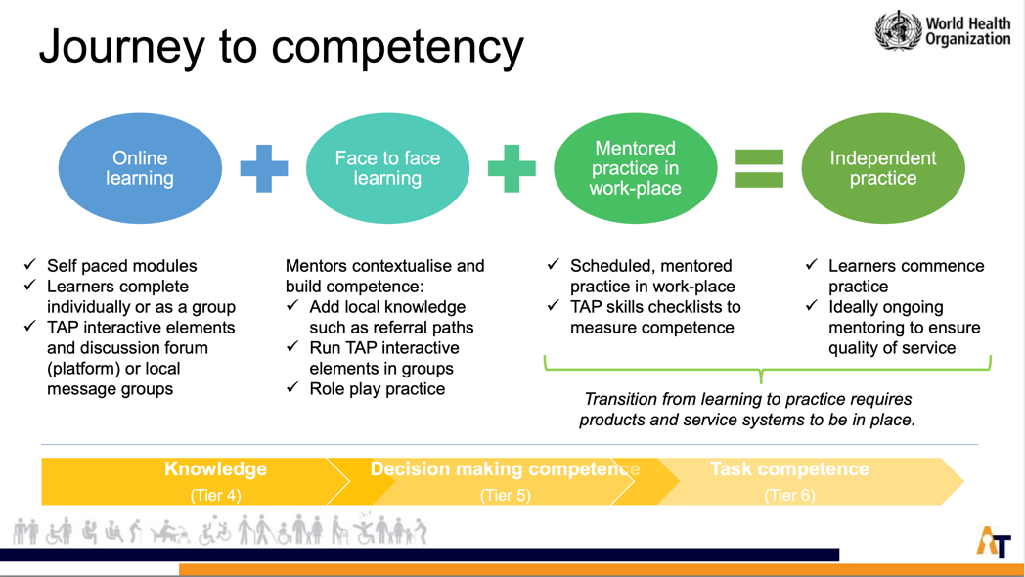

TAP includes assistive products from WHO’s Priority Assistive Products List (APL). The training programme is structured into modules, which are organised in six streams: 1) cognition, 2) communication, 3) vision, 4) hearing, 5) self care and 6) mobility. Each stream has an introduction module followed by product modules.

All learners are required to initiate TAP training by taking an overall “Introduction to Assistive Products” module which provides an overview of assistive products, four steps in delivery assistive products, and foundational knowledge and competencies. Further modules are then determined by the context.

Annex B: TAP learners

TAP Modules are written in plain English and designed for learners with no prior knowledge of assistive products.

Health personnel identified as learners should have the capacity and support from their managers to carry out assistive product service delivery. It may also be relevant and helpful to include managers in aspects of the training, for example the Introduction to Assistive Products module.

The table below provides an overview of criteria for selection of learners:

Criteria for selection of participating health personnel
Demographics and role:
- Aged between 18-50 years
- Health personnel with one of the following qualifications: nurse, nurse aide or physician’s assistant
- Available to participate in the training (sufficient flexibility in their schedule)
- Available to include provision of assistive products in their role after training
- Permanent employee of the MOH (on the payroll)
Competencies:
- Know how to carry out a person centred interview to gather information
- Know how to complete documentation such as a screening or assessment forms
- Knowledge of health and other related services in their area and how to refer to them
- The capacity to learn and carry out simple tests, with the support of a mentor
Additional considerations:
- From each centre there should be at least one male or one female to ensure gender balance
- Individuals identified should be interested and willing to participate
- Previous experience of using a computer (not essential)

Annex C: TAP Mentors

When TAP is used to build the competencies (skills) of staff, practice with a mentor is essential.

The table below outlines the risks that can be minimised through the use of in-person mentors, and the requirements of mentors for specific assistive products:

Product | Risks to avoid by using mentors | Mentor requirements
 |  | Knowledge and skills | Possible professions (must have relevant experience and training)
[Add module]
[Add lines as required]

Mentors role:

- During the online training component, the role of in-person mentors will include:
- Preparing the assistive products and other resources needed to take each module
- Providing support, answering questions and facilitating discussion as learners go through each module
- Setting up supervised sessions for practicing and developing skills
- Monitoring and assess competencies using TAP skills checklists

Note: Mentors are not required to prepare and/or deliver training. The training content is all provided through the platform. Their role is to provide mentoring to learners, sharing their skills in the specific product area they are supporting.

- During the supervised practice phase, mentors will make regular in-person visits to observe and provide additional mentoring as learners carry out AT service delivery.

Mentor identification and briefing steps:

- Identify mentors meeting the above requirements, and confirm their availability:
  - During the online training
  - To travel to provide in-person mentoring.
- Provide mentors with an overview of TAP (using TAP PPT), the plan for implementing TAP in-country, and request them to register on the TAP platform and take the online modules they will be mentoring.

Mentors | Modules they need to take
[Enter]

- TAP mentors virtual meeting, including TAP HQ team, to discuss mentors experience with the modules, clarify the mentor’s role, and introduce tools such as the skills checklist.
- Individual briefing with TAP HQ team on Walking aids, Toilet and shower chairs and Absorbent products for content specific questions.
- WhatsApp group established for mentors to ask technical questions of the WHO HQ team as required.

Annex D: TAP implementation and resources

Online training: During each training block, learners will undertake the online modules at their own pace and individually, using a desk top computer or tablet, under the guidance of mentors. In order to facilitate learning and ensure the online TAP content is contextualized, learners will also be engaged by the in-person mentors in peer discussion and role play opportunities to practice new skills.

Supervised practice: After the completion of the online training, learners will begin provision, with support from their mentors. Learners and mentors will be able to use TAP skills checklists to monitor their performance against key competencies

The necessary resources to host the online training and for learners to begin practice include:
- Venue and equipment for online training component:
  - Comfortable seating with desks for online learning
  - Space for group discussion and practice
  - Tablets and/or desk top computers with reliable internet access for learning participants
  - Headphones for learning participants
  - Folders and printed module documents (downloaded from TAP) for each learner
  - Specific equipment that may be required for specific products (for example a tape measure is required to fit walking aids)
- A range of each of the products included in the training modules including:
  - Samples for the online training component
  - Supply for learners to provide

Annex E: Registration and service delivery form example

[This form is an example only. You will need to create a form that is appropriate for the services being provided and to collect the data that you require.]

- Information about the service

Health facility | Add name □ |  | Add name □
 | Add name □ |  | Add name □
 | Add name □ |  | Add name □
Name of person providing assistive product |  | (Potentially auto-fill in app)
Date assistive product provided |  | (Potentially auto-fill in app)

- Information about the person

Name |  |  |  |  |  | Gender | Male □ | Female □ |  | Other □
Age |  | 0-5 □ 6+ □ 19+ □ 40+ □ 60+ □ |  |  |  |  | Date of birth
Email |  |  |  | Telephone
For parent/guardian of children under 18 years
Parent/guardian name
Parent/guardian telephone and/or address
Ask the person and/or their parent/guardian [optional questions if data on disability and/or need for assistive products is required]
Do you have any physical or mental health conditions or illnesses lasting or expected to last 12 months or more? Yes □ No □
Do any of your conditions or illnesses reduce your ability to carry out day-to-day activities?
Yes, a lot □ Yes, a little □ Not at all □
Do you have difficulty with: | Mobility □  Seeing □ |  | Hearing □  Self-care** □ |  |  | Speaking or communicating □  Remembering, thinking or concentrating □
*Mobility includes sitting, standing, walking or climbing steps.
**Self care includes going to the toilet, getting dressed, eating and drinking.

- Consent
[Insert question/s appropriate to the project and local data protection laws. Consent questions should always be verified by an ethics committee where research is involved.] | Yes □ No □

- Actions

Mobility products provided [these are examples – replace with the products that are being provided] |  | Date
Walking aids | Walking stick One size 
 | Axilla crutches One size 
 | Elbow crutches Small  Large 
 | Walking frame Small   Large  

Self-care products provided [these are examples – replace with the products that are being provided] |  | Date
Shower and toilet chairs | Toilet chair Child □ Adult □
 | Shower chair One size 

Referral made to another service [these are examples – replace with relevant referral services, as per products being provided]
Diabetic foot clinic □ | Out-patient rehabilitation □ | Ophthalmology □
Prosthetics/orthotics □ | Remarks: | _____________________

Other assistive product needs identified
Does the person need any other assistive products (that you are not able to provide)? |  | Yes □ | No □
If yes, please specify product: | _____________________

